**PROJECT REPORT**

**INTRODUCTION:**

**TITLE OF PROJECT :**

**“4 – BIT ALU”**

**GROUP MEMBERS :**

1. ABDUL BASIT (20K-0333 , E2)
2. YASIR JAMAL (20K-0158 , E1)
3. ANAS HASSAN (20K-1726 ,E1)
4. MUHAMMAD WARZAN (20K-1649 ,E2)

**METHODOLOGY :**

In our project , we have performed addition , subtraction and comparison of two 4 – bit binary numbers along with both hardware and software implementation except multiplication which is carried only in software.

**ELECTRONIC COMPONENTS :**

* **FOR ADDITION :**

4- bit full adder IC (74LS83)

5 white Leds

* **FOR SUBTRACTION :**

4 – bit full adder IC (74LS83)

Inverter IC (7404)

4 green Leds

* **FOR COMPARATOR :**

XNOR IC (74266)

4 AND ICS (7408)

OR IC (7432)

2 Inverter ICS (7404)

3 yellow Leds

* **OTHER MAIN COMPONENTS :**

3 Breadboards , 9 – volt power supply , jumper wires along with simple wires and some 220 -300 ohm resistors .

**SOFTWARE USED :**

We have implemented whole circuit of our project in LogicWorks by dividing the whole circuit into several modules and testing each circuit operation individually .

**FLOW DIAGRAM :**

**ADDITION CIRCUIT :**

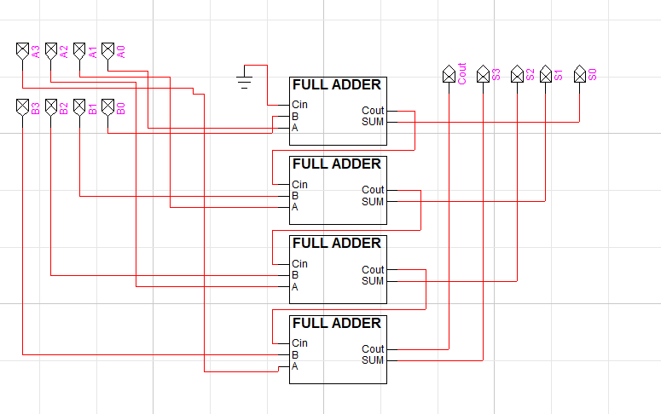

**SUBTRACTION CIRCUIT :**

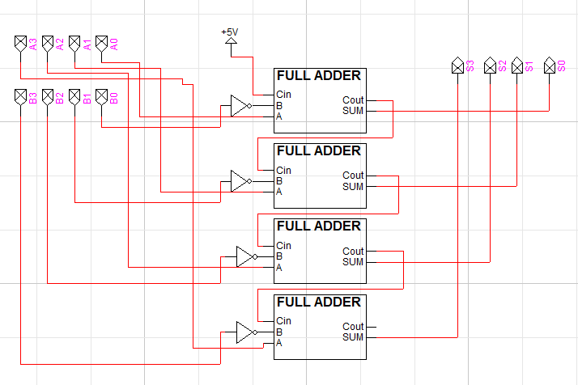

**MULTIPLICATION CIRCUIT :**

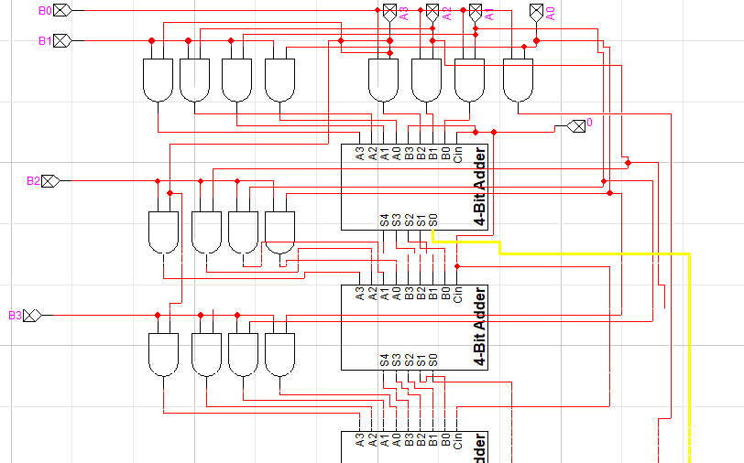



**COMPARATOR CIRCUIT :**

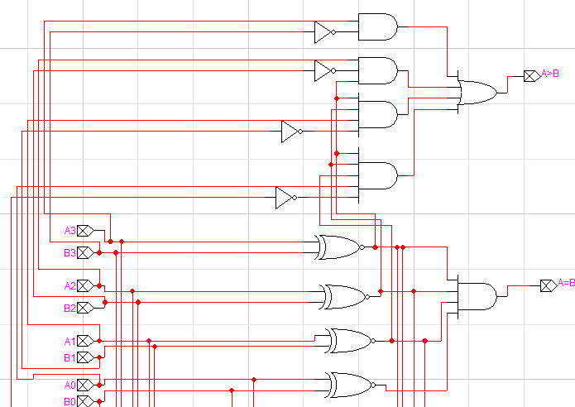

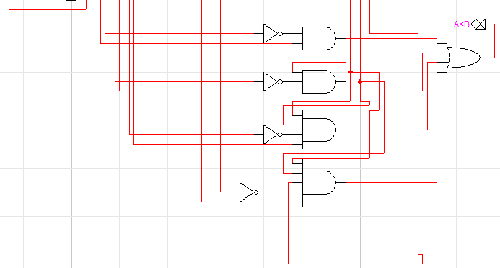

**OUTPUT WITH PROPER CAPTION :**

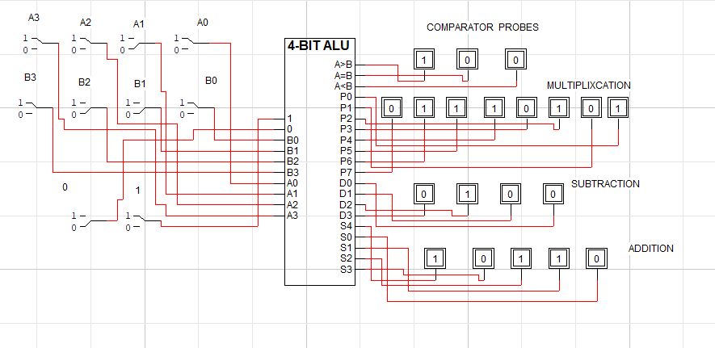

**FUNCTION / WORKING :**

We have used several ICS , Leds and 8- bit dip switches in implementation of project.

Addition and subtraction are performed in a single breadboard with a 8- bit dip switch that controls the output of both operations . 5 white and 4 green leds are used for this purpose respectively .

Similarly , comparator circuit is done in two breadboards due to complexity with a 8- bit switch and 3 yellow leds . Whenever one of the three conditions will be true , the respective led will be glown.

* A > B
* A = B
* A < B

**APPLICATION :**

An Arithmetic and Logic Unit (ALU) is a digital circuit used to perform arithmetic and logic operations . It represents the fundamental building block of the Central Processing Unit (CPU) of a computer.

**MOTIVATION :**

Since ALU is the most basic and fundamental part of the C.P.U , capable of performing all basic opertions . So , it motivates us to design such project which is capable of executing such operations .

**TASK DISTRIBUTION :**

All members of the group have equally participated in the hardware implementation of project but the workload distribution is given below.

* Abdul Basit (20K-0333) and Yasir Jamal (20K-0158) mainly worked on comparator circuit .
* Anas Hassan (20K-1726) and Muhammad Warzan (20K-1649) worked on addition and subtraction circuit.

**CONCLUSION :**

We have tried our best to design 4- bit ALU but unable to perform hardware implementation of multiplication due to less components and the current situation of the city but have completed with software implementation .We hope that you will surely like our project .

**THANKING YOU**